REFLECTION PRODUCTS

OUTSIDE CORNER MOUNTING BRACKET

These instructions apply to part numbers OCMB-26 for 18” and 26” convex mirrors

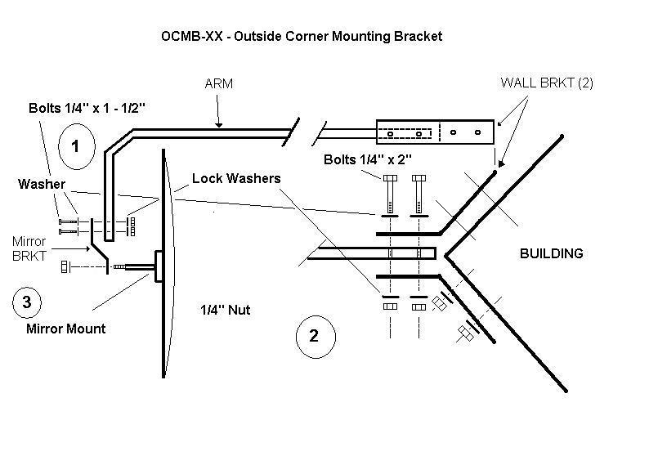
- Attach the Mirror Mount Bracket (3) to the front Arm (1) using two ¼” by 1 ½” bolts. The lock washer should be next to the nut otherwise the direction the bolts are installed is not important.
- Attach the two WALL Brackets to the ARM using two(2) ¼” x 2” bolts.
  - Hold the assembled bracket against the outside wall corner, at the location it is to be permanently placed. Mark and drill the holes for the expansion bolts if you are attaching to a brick or cement structure. (The included, 3/8” x 1-1/2 or 3” Hex Sleeve Anchor bolts require a 3/8” cement drill bit.) Otherwise use what is best for your situation.
- Attach the Arm assembly to the wall.
- After the Arm is securely mounted to the building, attach the mirror swivel mount shaft directly onto the Mirror bracket. You will not need the extra wall bracket included in the box with the mirror. Loosen the three screws around the ball swivel on the mirror (around ½ turn each) before trying to change the position of the mirror. Tighten the screws after the mirror has been positioned. 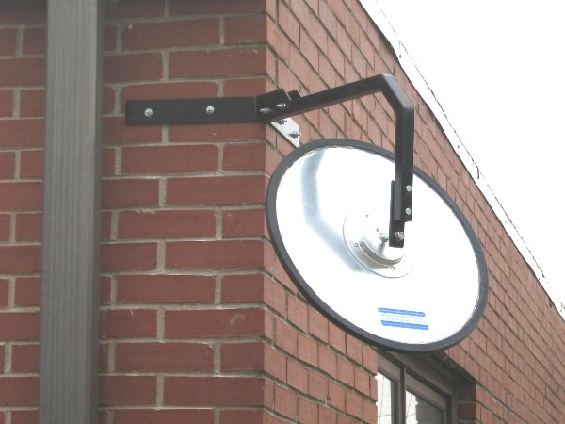
PARTS LIST:

QTY Description
1 ARM
2 Wall to ARM Attachment Brackets Bracket to attach the mirror to the ARM
1 Bracket to attach the mirror to the ARM
2 2” x ¼” BOLTS
2 1 ½” x ¼” BOLTS
- ¼” NUTS
4 ¼” WASHERS
4 3/8” Hex Sleeve Anchor Bolts
1 Instructions

ADDED NOTES:
- The 3/8” (included) Anchor bolts will require a 3/8” Cement Drill bit. The cement bit is NOT included with this kit. The Anchor bolts (included) were designed to be used on brick surfaces. If the surface is Cement or wood…etc, you may need to obtain appropriate fasteners needed for that surface.
- Use pliers to hold the swivel shaft from turning when you tighten the nut that holds the mirror to the mount. Otherwise it is difficult to tighten the nut well enough to prevent the mirror from spinning or coming loose.
- If the mount is protruding into an alleyway, consider that it must be mounted high enough so a large truck can safely pass under the bottom of the mirror.

